# EXPERIMENT 1

INTRODUCTION TO LABORATORY INSTRUMENTS

Distance education version of the experimental works go on in two main parts as simulations (by students) and after that interactive online demonstrations (by assistants) in the laboratory.

## 

## 1.1 Objective:

## 

In this experiment, LTspice simulation program, multimeters and some circuit components are introduced. You will learn the following things:

1. Reading the color codes and surface mount devices (SMD) type codes of resistors.
2. Using a multimeter for resistance measurements.
3. Measuring DC currents and voltages with a digital multimeter in a resistive circuit
4. Characteristics of resistors in parallel and series with using simulator

## 1.2 Equipment List:

* LTspice simulation program (you will download and setup your personal computer) (free licence:

[https://www.analog.com/en/design-center/design-tools-and-calculators/ltspice-simulator.html#](https://www.analog.com/en/design-center/design-tools-and-calculators/ltspice-simulator.html) )

**The equipments below are just for interactive online demonstration, you will not provide**

* Multimeter,
* CADET,
* Carbon Resistors (one 3.3kΩ, three 10kΩ, one 1kΩ)

## 

## 1.3 Experimental Work: Theoretical solutions

Note: You must perform your solution in std_number.pdf format prepared by any text based program i.e. word, LaTeX, Overleaf etc., handwriting, photographed, scanned reports will not accept. Also, your reports are scanned in Turnitin please do not share your reports and results from each other.

1. Solve the circuits given below (Figure 1, 2, 3, 4 and 5); find the all currents and voltage values where R1=1 kΩ, R2=10 kΩ, R3=3.3 kΩ.

|  |  |
| --- | --- |
| **Figure 1** | **Figure 2** |

|  |  |
| --- | --- |
| **Figure 3** | **Figure 4** |
| **Figure 5** | |

1. Calculate the current (I11) of the circuit in Figure 6 by using node analysis. Calculate the equivalent resistance (Rab) by using this current.

Note: To simplify calculations use 10/3.3 ≈ 3.

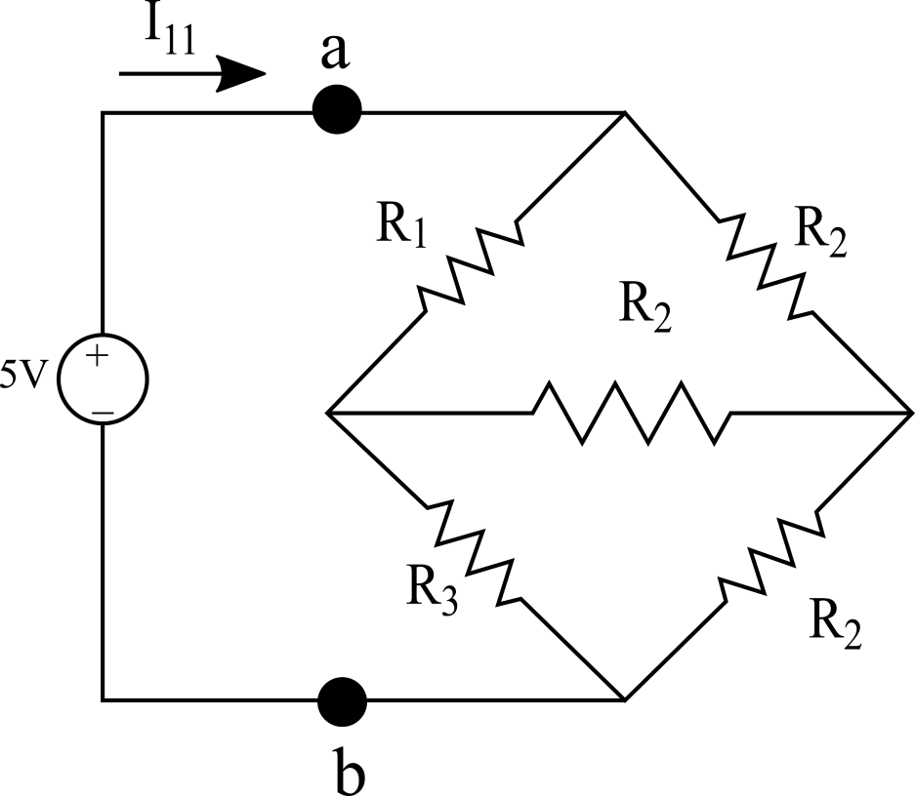

**Figure 6**

1. Write the color codes of resistors at Table 1 according to the Table 2

**Table 1**

|  |  |
| --- | --- |
| Resistors | Color Codes (10% Tolerance) |
| 22 kΩ |  |
| 3.3 kΩ |  |
| 12 kΩ |  |
| 18 kΩ |  |
| 1 MΩ |  |

**Table 2**

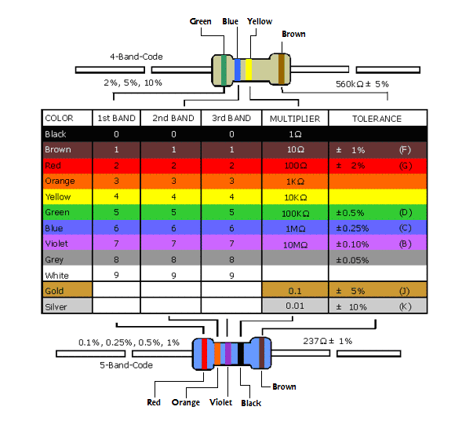

1. Write the resistance value of SMD resistors and show the how to calculate at Table 3 according to information about SMD resistor codes and Figure 7

**Table 3**

|  |  |  |
| --- | --- | --- |
| SMD Resistor | Resistance Value | Calculation method |
|  |  |  |
|  |  |  |
|  |  |  |
|  |  |  |
|  |  |  |

**Information about Surface Mount Devices (SMD) resistors:**

Surface Mount Devices (SMD) type resistors are widely used in electronics. They are prefered instead of classic types (metal pins) because of their small volume, easy assembly and cheap. They have different sizes standards which widely used ones are 1206, 0805, 0603 and 0402. These numbers refers the SMD resistors dimensions in inches and they are not written on the resistors, it is just known by designer (Fig. 7-a and Fig. 7-b). The white number on the black part of the resistor refers the resistance value. The calculation method changes with respect to digit number. Detailed and examples can be seen from Fig. 7-c. An example in Fig.8, demonstrates both classical and SMD resistor assembly in a PCB circuit.

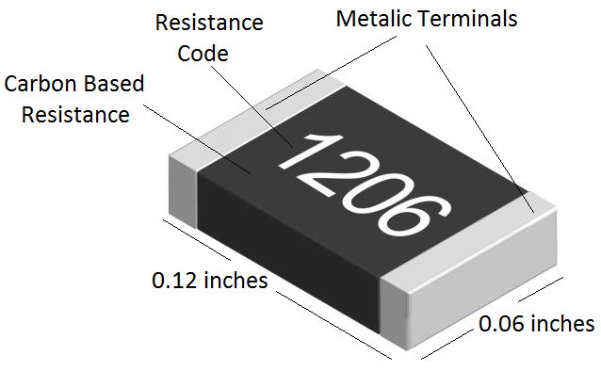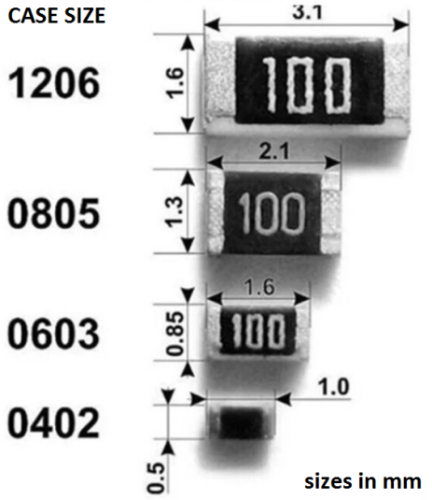

1. **(b)**

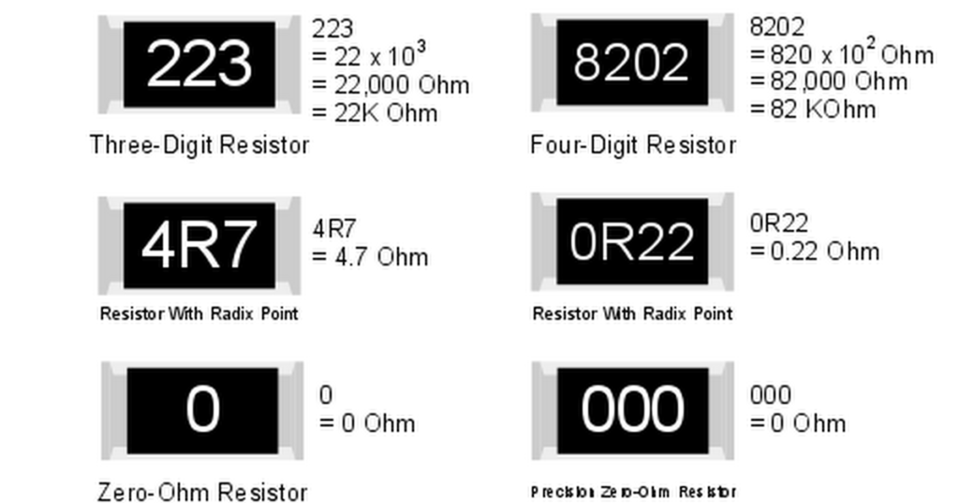

**(c)**

**Figure 7.** SMD resistor sizes and codes

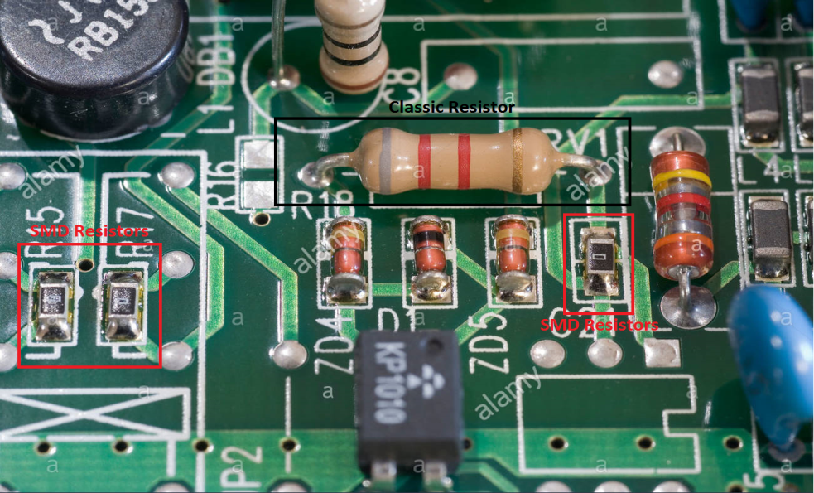

**Figure 8. Classic and SMD resistors**

## 1.4 Experimental Work: Simulation Solutions

## 

## Show your work in details and within order in the report for each step.

**1.**

* + 1. Setup the circuit in Figure 1 using LTspice. Define the resistance value as 1k Ohm and run the simulations (1s simulation time is enough). Plot a current and voltage graph on the resistor.
    2. Again in Figure 1 circuit, define the resistor resistance with 1%, 5% and 10% tolerance respectively (resistance value for tolerance 1%: **{mc(1k,0.01)}** , for 5% : **{mc(1k,0.05)}** , for 10% : **{mc(1k,0.1)}** ). Plot a current and voltage graph on the resistor for each tolerance value.
    3. Compare the toleranced and nominal results of the resistors. Determine the worst cases for tolerances.

**2.** Set up the circuits using LTspice given at Experimental Work: Theoretical solutions part in Figure 2,3,4,5 (except figure 1). Define the all resistors with tolerances 10% (resistance value for tolerance 10%: **{mc(1k,0.1)}**). Measure and plot all the currents and the voltages using the LTspice probes. Compare your theoretical results with your simulations results.

**4.** Set up the circuit using LTspice given at Figure 6. Define the all resistors with tolerances 10% (resistance value for tolerance 10%: **{mc(1k,0.1)}**). Measure and plot voltage (Vab) on the equivalent resistance (Rab) and current (I11) using the LTspice voltage and current probs. Compare your simulation results with your calculations (Also calculate Rab using simulation results).

**5.** Give a brief conclusion about what you have observed in the simulations(s).

Note: Please see the video tutorial for experiment 1 for assigning the tolerance to the resistances. (<https://youtu.be/aLQqeij4Or8>)

## 

## 1.5 Laboratory Demonstrations: Supplemental Knowledge

**i.** Make sure that you have the necessary instruments and components. The layout of breadboards on your cadets is shown below. All circuits will be set up on these breadboards during lab sessions. The breadboards have a set of holes spaced 0.1 inches apart and arranged in a pattern similar to that shown below. There are two horizontal lines with several groups of five holes in each line at the top and bottom edge of the board. Holes on breadboard, shown in Figure 7(a), are electrically interconnected as shown in Figure 7(b). There are two sets of vertical lines with five holes in each line at the center section of the breadboard. There is 0.3-inch space between the top and bottom set to match the standard spacing of pins on integrated circuit (IC) chips. The holes will accept the solid wire leads of most electronic components.

|  |
| --- |
| (a) |
| (b)  **Figure 7.** **(a)** Top view, **(b)** inner connections of breadboard |

A configuration example of three resistors in series on breadboard is shown in Figure 8.

|  |
| --- |
| **Figure 8.** Configuration example of resistors on breadboard |

**ii.** To measure the ***voltage across*** a resistor, the voltmeter must be connected to the resistor in parallel as shown in Figure 9.

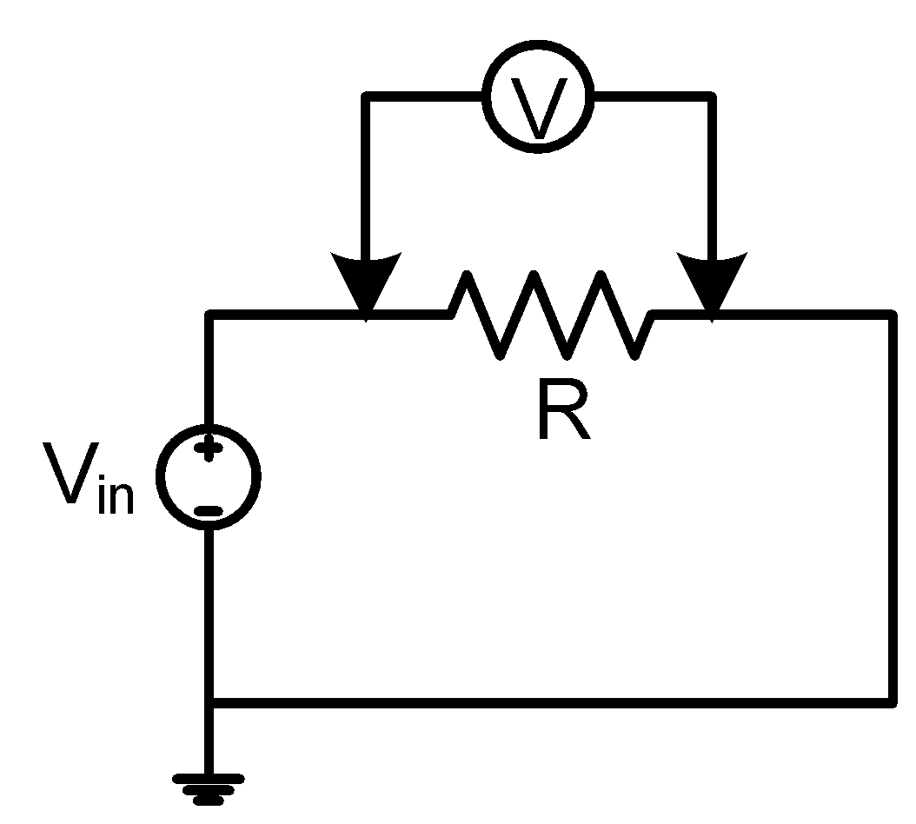

**Figure 9**

To measure the ***current through*** a resistor, the amperemeter must be connected to the resistor in series as shown in Figure 10.

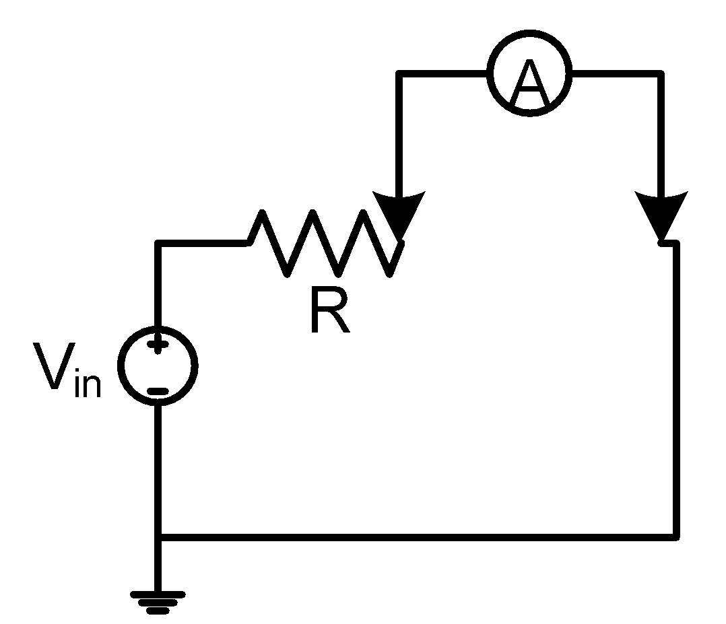

**Figure 10**

EE281 EXPERIMENT 1

## REPORT SHEET

Name & Surname :

Date :

1. **Experimental Work: Theoretical solutions**

Your theoretical solutions must be here in order like experiment sheet. You must use a text based program such as word, LaTeX, Overleaf etc.

Comment:

1. **Experimental Work: Simulation solutions**

Your simulation circuits drawn in LTspice and results must be here in order like experiment sheet. You can use snipping tool, powerpoint, paint or any picture editor for taking circuits and results from LTspice screen.

You can study the LTspice tutorials that we provide for your problematic issues.

After obtained results, please fill and put the table given below end of this section.

|  |  |  |  |  |  |  |
| --- | --- | --- | --- | --- | --- | --- |
|  | Voltages | |  |  | Currents | |
|  | Simulation | Calculated |  | Simulation | Calculated |
| V1 |  |  | I1 |  |  |
| V2 |  |  | I2 |  |  |
| V3 |  |  | I3 |  |  |
| V4 |  |  | I4 |  |  |
| V5 |  |  | I5 |  |  |
| V6 |  |  | I6 |  |  |
| V7 |  |  | I7 |  |  |
| V8 |  |  | I8 |  |  |
| V9 |  |  | I9 |  |  |
| V10 |  |  | I10 |  |  |
| V11 |  |  |  | | |
| V12 |  |  |

Comments:

1. **Conclusion:**

This part is prepared after online laboratory demonstration. You must compare the results from your simulations and online laboratory demonstration. Also, answer the questions from online laboratory demonstration.

Comments:

Q-1: How many measurement terminals of multimeter are used when measuring resistance, current and voltage? What is the importance of the polarity of the measurement terminals?

Q-2: How to connect the ammeter and voltmeter to the measured element? Parallel or series and how?

Q-3: If I used 1 Ohm instead of 1k Ohm in figure 1 circuit, what happens on the physical circuit?

Q-4: How tolerances distort measurements for circuits containing resistors only? How the situation changes for serial and parallel connections.